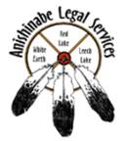
TRIBAL vs. STATE JURISDICTION:
What are the Differences?

Introduction

If you are struggling to choose whether to file your petition in tribal court or state court, this Fact Sheet is for you!!

This Jurisdiction Fact Sheet is meant to briefly explain the advantages and disadvantages of filing in either tribal or state court.

Why does it matter in which court I file?

The decision to file in a particular court, whether it be your county’s state court or your Band’s tribal court, could have immense impact on the outcome of your case.

Depending on the type of case you are filing, the first difference you will notice is the cost. The fee for filing in state court is typically higher than that of tribal court. While both jurisdictions offer in forma pauperis forms (a special request to have filing fees waived, based on specific income requirements),

the likelihood of that request being granted is
higher in tribal court than it is in state court.

The next most immediate difference you will
notice is the time in which your issues are resolved.
Generally speaking, state court dockets are much
busier, and therefore, your case will take longer
to come to an end. Whereas in tribal court, because
there are generally fewer litigants, your case will
proceed through the litigation process and a quicker rate.

The formality of the proceedings will also likely be different. State courts tend to cling to the traditional formalities of courtroom process. There are bailiffs. You will rise when the judge enters the room. The attorneys will all likely be dressed in suits. In tribal court, these customs are not usually followed. Both judges and attorneys, while still dressed professionally, will likely not be in full suits. The requirement to “all rise” will likely not occur. And unless specifically requested, a bailiff will probably not be present.
The outcome of the case may depend on which court you file in as well. State courts tend to follow rigid rules in deciding cases. These rules have been formed over many years and are generally referred to as the court’s precedent. (i.e. – how the court rules on a specific type of issue over time). This precedent is determined by that judge’s interpretations of the law, based on their own values and ethics. The values and ethics of a judge in tribal court will likely be influenced to some significant degree by tribal custom and tradition. In fact, in most tribal systems, the use of tribal custom and tradition is a required part of the jurisprudence of that court. What this means for you, as a party to the case, is that in state court, the judge may likely follow a rigid line of precedent in deciding if you win or lose. Whereas in tribal court, the judge may be more likely to look beyond the “rule of law” in helping parties find a more suitable resolution.

Are the laws different on the Red Lake Nation Reservation than in the state?

The answer to this question is tricky. The simplest way to understand the differences is to think of the tribes and bands as different states. While the different states’ laws will generally be quite similar, they will also deviate on a number of different issues.

Here is why tribal laws are different than state laws:
Tribes are sovereign nations within the geographical boundaries of the United States, subject primarily only to the laws of the federal government. This subjection is due principally to treaties made during the 18th and 19th Centuries. What this means is that, unless expressly instructed by the federal government through statute, tribes are not subject to state laws. That being said, many tribes (including the Bands that make up the Minnesota Chippewa Tribe) utilize state court language and policy in drafting their own codes.

Here in Minnesota, there is also what is colloquially known as PL280. Red lake Nation is not included in PL280, but almost all other Bands are. What PL280 means is that the tribes and bands within Minnesota are subject to the criminal jurisdiction of the state. The tribes and bands retain criminal jurisdiction over their own members; however, they lose that authority for non-member Native Americans and non-Natives.
**** Pro Tip **** Here in Red Lake, the Tribe retains both civil and criminal jurisdiction. While Red Lake Nation citizens may not be subject to the civil or criminal laws of the state while they are on the reservation, they are still subject to federal law.

Beyond that, tribal codified law is relatively new (only about 50 years old for some bands). So the degree to which tribal law has been reduced to a written statutory system is in some instances is minimal. The Red Lake Nation Codes are expanding all the time, but still do not cover every area of law imaginable. When the tribal code does not cover an area of law (for example personal injury), the tribal court will often look to the how the state deals with similar issues (though the tribal court is not necessarily required to do so).
If I am a member of the Red Lake Nation, but live off of the reservation, can I still file in tribal court?

YES! If you are a member of the Red Lake Nation, you can file your petition in tribal court no matter where you live! That being said, depending on your type of legal issue and how far away you live, you may still want to consider filing your petition in state court anyways. This is a personal decision you will have to make yourself. But before filing, consider the stress driving to court will put on you (it will likely be at least a few trips to court); the comfort of either the state or tribal system; and the costs associated with each.

What if I file in one court, but later decide that I should have filed in a different court?
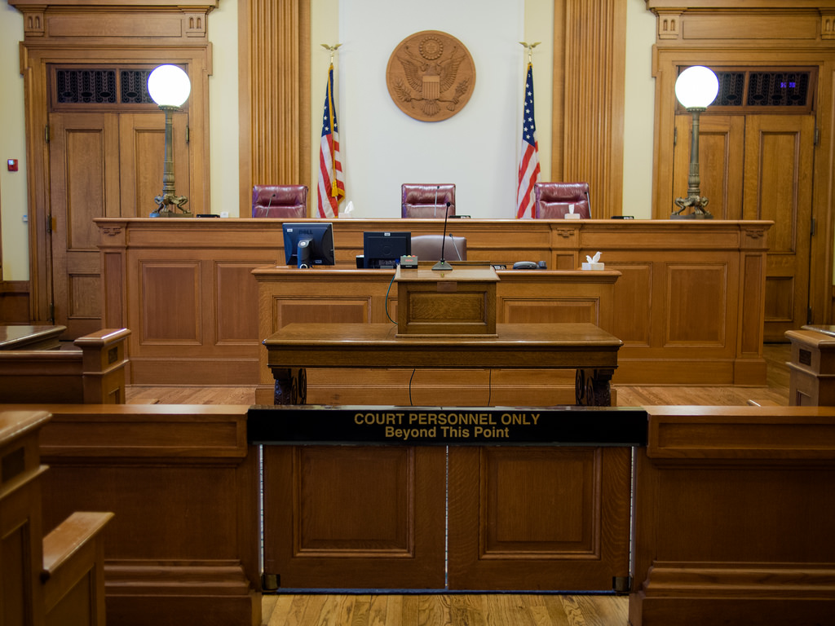

Unfortunately, as the petitioner (the one filing
the law suit), you are generally going to be bound
to the court in which you initially file your petition.
So make your decision carefully! Court systems
have long frowned upon what is called “forum
shopping.” This is a practice wherein a petitioner
will file in one court, but then move to another
court when he or she becomes dissatisfied with how their issues are being dealt with in the first court. This puts unnecessary burdens on court dockets, lawyers, respondents, witnesses, and any number of other people involved in the case. If you are uncertain about where you should file your case, consult with an attorney beforehand.

While petitioners are generally bound to the court they file in, the respondent (the “defendant” in the law suit) will typically get one chance to ask for a change in forum or venue before proceeding through the case. The respondent should do this at the very beginning if he or she wishes to move the case to a different court. Typical reasons for a respondent to want a change in court include geographical location, location of witnesses, or location of where the events occurred.

Can I be served legal papers if I am on the Reservation?

Yes. Being on the Reservation will not prevent a process server from being able to serve you with court documents. Be advised that refusing to accept service will likely result in a court determining that you were given notice anyways. If someone attempts to serve you with papers, it is best to simply accept them and contact your local legal aid office right away.

Likewise, non-members and non-Natives do not have to sue you in tribal court simply because you are a tribal member. The petitioner gets to choose the court in which they file, and if all or even part of the events occurred off of the reservation, the petitioner will be able to sue you in the state court in that county.

Will orders issued in tribal court be enforceable outside of the reservation (and will state orders be enforceable within the reservation)?

Yes on both counts! Tribal courts are just as powerful
as any state or federal court. The orders issued

in a tribal court will generally be treated within
the state the same way orders from other states
are treated. That being said, states are not
required to enforce the orders of other states
(or of tribal courts). It is through comity
(unspoken mutual understandings) that states
agree to enforce those orders. This is because
they want those other states and tribes to enforce their orders too.

The same ideas of comity apply to tribal orders being enforced in states as well. States want their orders to be enforced in Indian Country, so they generally agree to enforce tribal orders as well.

If ever a state official chooses not to enforce your tribal order (or if a tribal official chooses not to enforce your state order), file a document with that court called a “motion to enforce foreign order.” This will essentially make your tribal court order a state court order by having a state court judge agree to it.

Orders for Protection
Protective orders (usually arising out of domestic violence situations) are always enforceable no matter where you are. If you received an OFP from a tribal court in northern Minnesota, that OFP will be enforceable in Florida, Texas, Navajo Nation, or any other location within the United States. If you have an OFP, always keep a copy of it with you whenever you travel.

Can state police arrest me if I am on the Red Lake Nation Reservation?

Specifically for Red Lake Nation, no. This is due to Red Lake Nation’s unique relationship with the state and federal governments. You may have heard the Red Lake Nation referred to as a “closed” reservation. This is because of the Red Lake Nation was not included in the 1855 Minnesota Chippewa Tribe treaty with the United States, and has continued to hold itself out as distinct from the other Nations within Minnesota. This is not to say, however, that you will be free from prosecution if you commit a crime outside of the Red Lake Nation reservation and then return to the reservation. State police can still issue warrants, and depending on the severity of the crime, and the willingness of the Red Lake Nation to participate, you may still be arrested by Red Lake tribal police and transported into the state. You may have also violated a federal law, thus allowing BIA police to apprehend you.

Generally speaking for the other reservations here in Minnesota however, yes. Bands have signed on to a joint state-tribal law enforcement agreement, allowing state police to enter into tribal lands to affect a warrant. The same is true for tribal police being able to make an arrest of one of its own members outside of reservation territory.

If you are a tribal member, who has committed a crime which violates both tribal and state law, be advised that you can be prosecuted by both the tribe and the state in separate criminal cases. Because they are separate sovereigns, both the tribe and the state will be able to prosecute and punish. That being said, the maximum amount of jail time for a violation of a tribal criminal law is generally one (1) year, unless the specific band has adopted the provisions of the Tribal Law and Order Act. In which case, the maximum sentence for any tribal crime is three (3) years. Depending on the crime, and the age of the accused, you may also be automatically subject to federal jurisdiction as well. If you have been charged with a crime, and are a member of a sovereign Indian nation, there may be resources available to you. Please contact your regional legal aid office for more information.

Resources

Court forms are available at the Red Lake RTC Judicial Annex, or on the Anishinabe Legal Services Website at www.alslegal.org. Additional resources may be found at www.LawHelpMN.org. For specific questions regarding your legal problem, call the Minnesota Legal Aid Directory at (218) 751-9201 or Anishinabe Legal Services at (218) 335-2223 [toll-free at 1-800-422-1335].

Please be advised that these Legal Aid Fact Sheets are intended to provide legal information only for those representing themselves and are not intended to operate as legal advice. Nor will the use of such Legal Aid Fact Sheets create an extended Attorney-Client relationship. If you are in need of legal representation in an upcoming case, ask about meeting our financial qualifications when you call to do your intake.

*These Legal Aid Fact Sheets are made possible by the generous funding provided by the Otto Bremer Trust.


Last Updated July 23, 2018

